Sport | Age Group | T&D Trial Date | T&D Convenor & Venue |  | T&D Coach and Manager | Regional Trial Dates  Venue and Convenor |  | State Carnival  Dates and Venue
Swimming  Nominations due  17th February | 10-19 Years | 13 Feb | Combined with M&D  Miles  3x Tara  2 x small school school – Anna  1 meet manager - Kylie |  | Moonie / Meandarra  Glenmorgan | 24 February  St George |  | 10 – 12 yrs 25 – 27 March  Chandler
Basketball Boys | 10-12 Years | Tuesday 26 May  4.00pm | The Gums – |  | The Gums | Thursday 18 June  Toowoomba – in conjunction with DD |  | 3-6 September  Carina
Basketball Girls | 10 – 12 yrs | Tuesday 24 March  4.00pm | The Gums |  | The Gums | Tuesday 28 April  Roma | Thursday 18 June  Toowoomba | 3-6 September  Carina
Touch Boys | 10-12 Years | Thursday 7 May  4.00pm | St Joseph’s |  | St Joseph’s | Tuesday 9 June  Chinchilla |  | 13 -16 August  Bundaberg
Touch Girls | 10-12 Years | Thursday 7 May  4.00pm | St Joseph’s |  | St Joseph’s |  |  | 13 -16 August  Bundaberg
Football Boys | 10-12 Years | Thursday 30 April  4.00pm | Hannaford |  | Hannaford | Wednesday 3rd June  Chinchilla |  | 6-9 August  Tingalpa
Football Girls | 10-12 Years | Thursday 30 April  4.00pm | Hannaford |  | Hannaford |  |  | 6-9 August  Tingalpa
Netball | 10-11 Years  mixed | 25 Feb | Teelba – Siobhan – in conjunction with Come and Try |  | Siobhan - Teelba  Westmar TBA | Tuesday 31st March  St George |  | 30 -31 May  Nathan
Netball | 10-12 Years | 25 Feb | Teelba – Siobhan – in conjunction with Come and Try |  | Siobhan - Teelba  Westmar TBA | Monday 30 March  St George |  | 28-31 May  Nathan
Orienteering | 11-19 Years | Wednesday 25 March  4.00pm | The Gums |  | The Gums | Tuesday 13 May (TBC)  TBC |  | TBC
Rugby League Boys | 11-12 Years | 12th March 4pm | Tara |  | Tara | Wednesday 22 April  Miles |  | 25 – 30 June  Bundaberg
Rugby League Girls | 11-12 Years | 12th March 4pm | Tara |  | Tara | Thursday 4th June  Tara |  | 17 – 20 September  Robina
Cross Country  Nominations close  12 May | 10-19 Years | Thursday 23 April | The Gums |  | The Gums  Tara | Tuesday 19 May  Chinchilla |  | 18-20 July  Highfields
Softball Girls | 10-12 Years | Tuesday 26 May  4.00pm | Tara – Chloe P |  | Chloe P | Tuesday 16th June  Charleville |  | 19-22 August  Ormiston
Tennis Boys & Girls | 10-12 Years | Wednesday 18 March  9.30 am | Tara – Ros and Jo |  | Jo Savill | Tuesday 12th May  Roma |  | 23 -26 July  Carseldine
Cricket Boys | 10-12 Years | Thursday 21 May  4.00pm | Tara Showgrounds |  | Cooper L  Tara | Tuesday 14th July - Roma |  | 14-18 – September  Ipswich
Cricket Girls | 10-12 Years | Thursday 21 May  4.00pm | Tara Showgrounds |  | Cooper L  Tara | Tuesday 14th July - Roma |  | 8-11 – September  TBC
Track and Field  Nominations Close:  Monday 23 August | 10-19 Years | Thursday 6 August | Meandarra |  | Tara x 4  Small schools x1 | Thursday and Friday 27 -28 August  Chinchilla |  | 10 – 12 yrs 12-14 October  Brisbane
Aquathlon | 11-12 Years |  |  | nominations | Glenmorgan | Friday 20 October (for 2027)  Dalby – in conjunction with DD |  | 5-7 February (2026)  Hervey Bay
Squash | 10 – 19yrs |  |  | Michael Dorr | Tara | Friday 6 March  Crows Nest – in conjunction with DD |  | 14-17 May  Cairns

Tara & District Primary Sports Calendar 2026
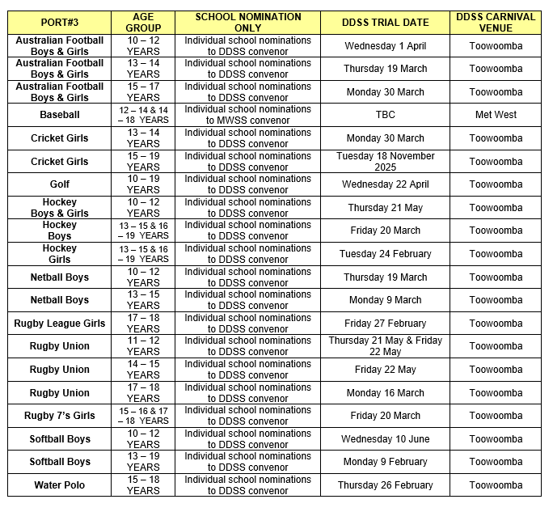

Tara & District Secondary Sports Calendar 2026
Sport | Age Group | T&D Trial Date | T&D Convenor & Venue | T&D Coach and Manager | Regional Trial Dates  Venue and Convenor |  | State Carnival  Dates and Venue
Swimming  Nominations due  17th February | 10-19 Years |  |  |  | 24 February  St George |  | 13-19 years 22 – 24 March  Chandler
Touch Boys and Girls | 13-15 Years |  |  |  | Tuesday 21 April  Chinchilla |  | 6-9 August  Wavell Heights
Touch Boys and Girls | 16 -18 Years |  |  |  | Tuesday 21 April  Chinchilla |  | 11 -14 June  Townsville
Netball | 13-15 Years  16-19 Years |  |  |  | Tuesday 3 March  Chinchilla |  | 7-10 May  Nathan
Orienteering | 11-19 Years |  |  |  | Tuesday 12 May (TBC)  TBC |  | TBC
Rugby League Boys | 13-14 Years |  |  |  | Friday 19 June  Chinchilla |  | 17-20 September  Highfields
Rugby League Boys | 15-16 Years  17-18 Years |  |  |  | Wednesday 4 March  Roma |  | 21 -24 May  Browns Plains
Rugby League Girls | 13-14 years |  |  |  | Thursday 16 July  Toowoomba in conjunction with DD |  | 17-20 September  Robina & Mudgeeraba
Rugby League Girls | 15-16 Years |  |  |  | Friday 27 February  Toowoomba in conjunction with DD |  | 30 April – 3 May  Gladstone
Cross Country  Nominations close  12 May | 10-19 Years |  |  |  | Tuesday 19 May  Chinchilla |  | 18-20 July  Highfields
Squash | 10 – 19yrs |  |  |  | Friday 6 March  Crows Nest – in conjunction with DD |  | 14-17 May  Cairns
Tennis Boys & Girls | 13-19 Years |  |  |  | Thursday 8 October (for 2027)  Roma |  | 12-15 March 2026  Caloundra
Cricket Boys | 13-14 Years |  |  |  | Wednesday 16 September  Toowoomba in Conjunction with DD |  | 9-13 November  Toowoomba
Track and Field  Nominations Close:  Monday 23 August | 10-19 Years |  |  |  | Thursday and Friday 27 -28 August  Chinchilla |  | 13-19 yrs 15 -18 October  Brisbane
Aquathlon | 13-19 Years |  |  |  | Friday 20 October (for 2027)  Dalby – in conjunction with DD |  | 5-7 February (2026)  Hervey Bay
Triathlon | 13- 19 Years |  |  |  | Sunday 18 October  Kawana |  | 5-7 February  Hervey Bay
Basketball Boys & Girls | 13-16 Years |  |  |  | Wednesday 7 Oct  Roma SW | Tues 10 March  Toowoomba DD
Basketball Boys & Girls | 17-18 Years |  |  |  | Wednesday 7 Oct  Roma SW | Thurs 26 March  Toowoomba DD
Football Boys | 15 & 19 Years |  |  |  | Thur 22 Oct  Chinchilla SW | Thur 5 March  Toowoomba DD
Football Girls | 15 & 19 Years |  |  |  | Thur 22 Oct  Chinchilla SW | Mon 9 Mar  Toowoomba DD
Futsal Boys & Girls | 13-16 Years |  |  |  | Tues 16 June  Roma SW | Tues 28 July  Toowoomba DD
Softball Girls | 13 – 18 Years |  |  |  | Fri 9th October  Charleville SW | Mon 9 February  Toowoomba DD
