The 2026 regional 10 – 19 years TRACK & FIELD trials are to be held on Thursday 27th & Friday 28th of August.

Districts/schools are to conduct trials to nominate suitable teams/individuals to attend these trials.

Please note the following details:

DATE: Thursday 27th & Friday 28th of August 2026

TIME: Thursday Start Time 12:30pm, Friday Start Time 8:30 am

VENUE: Chinchilla Christian College, 88 Oak Street, Chinchilla 4413

AGES: 10 -19 – students born 2007 – 2016

WHAT TO BRING:

- Sunscreen
- Water
- First aid kit
- Head wear
- Food – a canteen will be operating
- Shade shelter / chairs

MEDICAL/PERMISSION FORMS:
All athletes must bring a completed SW trial permission form (RTPF) & Queensland School Sport consent form to the regional trial. NO FORM means the student will be unable to trial on the day.

SOUTH WEST TEAM:
At the conclusion of the trials, a team of qualified students will be selected to contest the state championships at Nathan from 12 – 14 October (10-12 years students) and 15 – 18 October (13 – 19 years students).

SELECTION PROCEDURES:
- Chief selector will be RSSO, Tim Leadbetter, in consultation with regional team officials and QSS Track & Field qualifying standards.
- District team officials will be consulted throughout the day on potential athletes.

MULTICLASS STUDENTS:
Multiclass students are eligible to be nominated for this regional trial. Multiclass athletes are to be nominated through meet manger as per the nomination process. Additionally, the multiclass entry list form (page 10) need to be completed and submitted with the meet manager nomination. Please only nominate students who have or an in the process of obtaining classification.


CODE OF CONDUCT:
This event is conducted under the QRSS code of conduct. The QRSS code of conduct can be found on the Queensland Representative School Sport website or using the following QR code:

NOMINATIONS CLOSE:
- Thursday, 20th August with:
- Tim Leadbetter
- South West RSSO
- EMAIL: Tim.Leadbetter@qed.qld.gov.au

Nominations are to be emailed to the RSSO using Meet Manager.
Regional trial permission / consent form summary are to be emailed to the RSSO at the same time as the nomination.
The program files for MM will be available from the SWSS by early Term 3 at the latest.

Regional Trial Permission / Consent Form Summary

Please complete details below regarding South West School Sport Regional Trial Permission / Consent Form for district team members. This form must be returned at the same time as the nomination to the regional convenor. The nomination due date can be found in the regional trial bulletin.

REGIONAL TRIAL DETAILS

Event: | SWSS Track & Field Trials | Venue: | Chinchilla Christian College | Dates: | 27-28 Aug 2026

Media Release Section (Swimming, Cross Country & Track & Field only): all Forms received and approval given. Yes or No (if no, please provide details below)

Full consent to publish student information has NOT been received for the following team members
Student name | Playing number | Special requirements or instructions

Regional Trial Permission Form: all permission on form received and approval given. Yes or No (if no, please provide details below)

Parent, Student and or School Permission has NOT been received for the following team members
Student name |  | Playing number
Team Manager (name): |  |  |  | Total Number of Student Nominations:
Team Manager (signature): |  |  |  | Date:

INFORMATION AND CONDITIONS
Convenor: Brianna Welsby
Chinchilla Christian College
E-mail: brianna.welsby@chinchillacc.qld.edu.au
Telephone: CCC – 4522 4000
- All nominations are to be emailed to the RSSO, Tim Leadbetter, by the closing date using Meet Manager or Team Manager Lite programs. The files for these programs will be available from the SWSS website by early Term 3 at the latest.
- District are to nominate to all students who have met the South West qualifying standards. DO NOT nominate students who have not attained these times/distances at your school/district carnival.
- District/s who do not forward their nominations by the due date will not have their athletes included in the program.
- Children's date of birth MUST be included in the Meet/Team Manager program. These are necessary for Regional Selection.
- All nominations MUST include the performances by the athlete at the DISTRICT/ SCHOOL Carnival/Trial. (i.e. better performance at other meets WILL NOT be recognised).
- Ages are calculated to the year of birth (e.g. a child born in 2016 is a 10 year old in 2026).
- A team manager, who is a teacher, must accompany each District team. Complaints, protests, scratchings, etc. will ONLY be received from the manager (i.e. not from parents).
- The proposed program for the Regional Carnival is enclosed with this information.
- Once nominations have been finalised, a summary of the events will be provided to each district/school. Please check this summary to ensure events are accurate and inform the RSSO of changes, additions, and scratchings before the carnival where possible.
- Students wishing to be considered for selection in events not held at the SWSS regional trials, must submit a nomination form to the RSSO. These forms to be submitted by the District Manager/School Sport Coordinator and to accompany the District/school nomination file.
- Students selected in the regional team will be announced and appropriate forms given to them during the carnival. There will be a presentation of trophies at the end of the day.

PARKING:
Parking is available along Oak and Rodger streets as well as the school carpark off Rodger St.

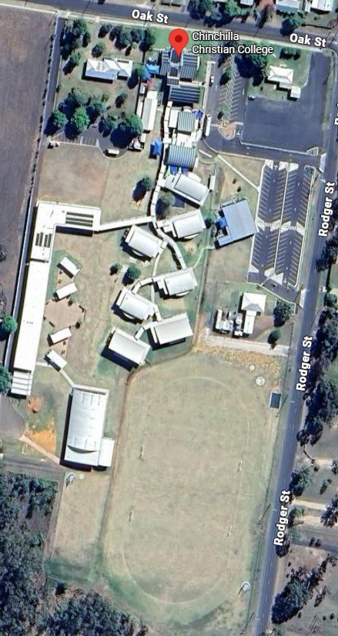
COMPETITION LAYOUT:

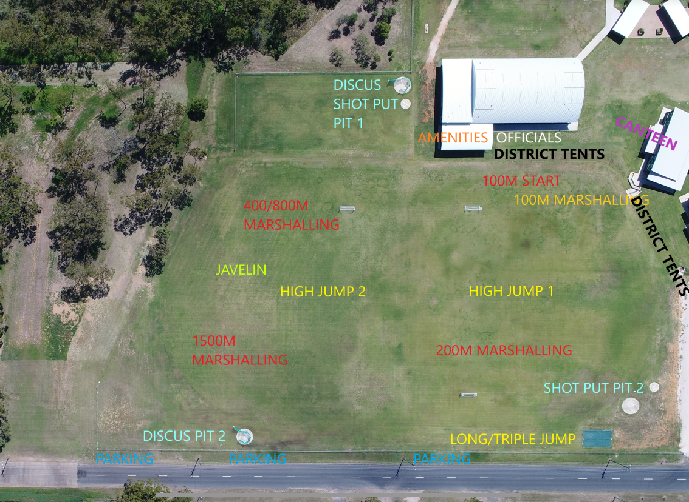

When competing in field events athletes are reminded that track events take priority. This means that if announcer calls for the marshalling of your age group for a track event, athletes must inform the field event official that they need to marshal for a track event and leave immediately to marshal at the track. Once the track event is complete, competitors must then return to the interrupted field event, inform the official of their return and complete their jumps/throws.

THROWING IMPLEMENT WEIGHTS:
Male | 18/19 Yrs |  | 17 Yrs | 16 Yrs | 15 Yrs | 14 Yrs |  | 13 Yrs | 12 Yrs | 11 Yrs | 10 Yrs
Shot Put | 6 kg |  | 5 kg | 5 kg | 4 kg | 4 kg |  | 3 kg | 3kg | 2kg | 2kg
Discus Throw | 1.75 kg |  | 1.5 kg | 1.5 kg | 1 kg | 1 kg |  | 1 kg | 750g | 750g | 500g
Javelin Throw | 800 g |  | 700 g | 700 g | 700 g | 700 g |  | 600 g
Female | 18/19 Yrs |  | 17 Yrs | 16 Yrs | 15 Yrs | 14 Yrs |  | 13 Yrs | 12 Yrs | 11 Yrs | 10 Yrs
Shot Put |  | 4 kg | 3 kg | 3 kg | 3 kg |  | 3 kg | 3 kg | 3kg | 2kg | 2kg
Discus Throw |  | 1 kg | 1 kg | 1 kg | 1 kg |  | 1 kg | 1 kg | 750g | 750g | 500g
Javelin Throw |  | 600 g | 500 g | 500 g | 500 g |  | 500 g | 400 g

HIGH JUMP STARTING HEIGHTS:

The below figures are the starting heights at which the bar will be set for the High Jump events. After competing at this height, the bar will be raised in the following increments:
BOYS
AGE | START HEIGHT | SUBSEQUENT CHANGES
10 Years | 1.09 | 1.14 | 1.19 | 1.22 | 1.25 | +3cm→
11 Years | 1.19 | 1.24 | 1.29 | 1.32 | 1.35 | +3cm→
12 Years | 1.27 | 1.32 | 1.37 | 1.40 | 1.43 | +3cm→
13 Years | 1.33 | 1.38 | 1.43 | 1.46 | 1.49 | +3cm→
14 Years | 1.46 | 1.51 | 1.56 | 1.59 | 1.62 | +3cm→
15 Years | 1.55 | 1.60 | 1.65 | 1.68 | 1.71 | +3cm→
16 Years | 1.55 | 1.60 | 1.65 | 1.68 | 1.71 | +3cm→
17 Years/Open | 1.42 | 1.47 | 1.52 | 1.55 | 1.58 | +3cm→
GIRLS
AGE | START HEIGHT | SUBSEQUENT CHANGES
10 Years | 1.02 | 1.07 | 1.12 | 1.15 | 1.18 | +3cm→
11 Years | 1.12 | 1.17 | 1.22 | 1.25 | 1.28 | +3cm→
12 Years | 1.19 | 1.24 | 1.29 | 1.32 | 1.35 | +3cm→
13 Years | 1.28 | 1.33 | 1.38 | 1.41 | 1.44 | +3cm→
14 Years | 1.31 | 1.36 | 1.41 | 1.44 | 1.47 | +3cm→
15 Years | 1.31 | 1.36 | 1.41 | 1.44 | 1.47 | +3cm→
16 Years | 1.31 | 1.36 | 1.41 | 1.44 | 1.47 | +3cm→
17 Years/Open | 1.16 | 1.21 | 1.26 | 1.29 | 1.32 | +3cm→

As per the changes made by Education Queensland, all students utilising the Fosbury flop technique must submit a certificate of competence in order to compete. Starting heights have been adjusted to reflect the variance for the scissor technique.

QUALIFYING STANDARDS

The following times and distances have been set after a review of results from the previous two years regional carnivals. District are to nominate to all students who have met the South West qualifying standards. DO NOT nominate students who have not attained these times/distances at your school/district carnival.

Event | Qualifying Standard
Event | 10 |  | 11 |  | 12 |  | 13 |  | 14 |  | 15 |  | 16 |  | 17 |  | 18/19
Event | B | G | B | G | B | G | B | G | B | G | B | G | B | G | B | G | B | G
100 | 17.50 | 18.00 | 17.00 | 17.50 | 16.50 | 17.00 | 14.10 | 15.30 | 13.70 | 15.30 | 13.50 | 15.30 | 13.25 | 15.30 | 13.25 | 15.30 | 13.25 | 15.30
200 | 38.00 | 39.00 | 36.00 | 37.00 | 35.00 | 36.50 | 29.50 | 32.75 | 29.00 | 32.75 | 28.50 | 32.75 | 28.00 | 32.75 | 28.00 | 32.75 | 28.00 | 32.75
400 |  |  |  |  |  |  | 76.00 | 83.00 | 71.00 | 83.00 | 71.00 | 83.00 | 69.00 | 83.00 | 68.00 | 83.00 | 68.00 | 83.00
800 | 3:20.0 | 3:35.0 | 3:15.0 | 3:30.0 | 3:15.0 | 3:30.0 | 3:05.0 | 3:22.0 | 2:55.0 | 3:22.0 | 2:50.0 | 3:22.0 | 2:50.0 | 3:22.0 | 2:47.5 | 3:22.0 | 2:47.5 | 3:22.0
1500 | 7:30.0 | 8:00.0 | 7:15.0 | 7:50.0 | 7:10.0 | 7:45.0 | 6:30.0 | 7:15.0 | 6:25.0 | 7:15.0 | 6:25.0 | 7:15.0 | 6:20.0 | 7:15.0 | 6:20.0 | 7:15.0 | 6:20.0 | 7:15.0
Long Jump | 3.00 | 2.80 | 3.25 | 3.00 | 3.55 | 3.20 | 3.80 | 3.40 | 4.15 | 3.50 | 4.40 | 3.50 | 4.55 | 3.50 | 4.55 | 3.50 | 4.55 | 3.50
High Jump | 1.09 | 1.02 | 1.19 | 1.12 | 1.27 | 1.19 | 1.33 | 1.28 | 1.46 | 1.28 | 1.55 | 1.28 | 1.55 | 1.28 | 1.42 | 1.16 | 1.42 | 1.16
Triple Jump |  |  |  |  |  |  | 8.50 | 7.40 | 8.90 | 7.40 | 8.90 | 7.40 | 8.90 | 7.40 | 8.90 | 7.40 | 8.90 | 7.40
Shot Put | 6.30 | 5.60 | 7.30 | 6.30 | 7.00 | 6.00 | 8.75 | 6.75 | 9.50 | 7.00 | 9.50 | 7.00 | 9.00 | 7.00 | 9.00 | 7.00 | 8.50 | 6.75
Discus | 17.00 | 13.00 | 17.00 | 13.00 | 20.00 | 15.00 | 21.50 | 15.00 | 25.00 | 16.00 | 26.00 | 16.00 | 24.00 | 16.00 | 24.00 | 17.00 | 24.00 | 17.00
Javelin |  |  |  |  |  |  | 21.00 | 16.00 | 24.00 | 16.00 | 24.00 | 16.00 | 24.00 | 16.00 | 24.00 | 16.00 | 23.00 | 16.00

TROPHIES PRESENTED:
1. Frank Snars Shield – Aggregate District Points [10 – 19 Years]
2. Neil Turner Shield – Percentage District Points [10 – 19 Years]
3. Age Champion Trophies – 10, 11, 12, 13, 14, 15, 16, 17, 18-19.
4. Record Certificates (Sent to schools after the regional trial)

DISTRICT POINTS SCORE AGE POINTS SCORE
1st - 7 1st - 7
2nd - 5 2nd - 5
3rd - 3 3rd - 3
NOTES:
- There will be no record attempts for all field events. If the winner of High Jump has not reached the qualifying height during the competition, s/he may attempt the qualifying height providing s/he has not already failed three consecutive attempts. All track events [except 10 – 12 Years 100m], the final place-getters will be determined by TIMES.
- Track event times are determined by the use of a semi-automatic timing system.
- Only times performances at the regional carnival are considered for events contested at the carnival.
- Any complaints, protests etc. MUST be lodged in writing, through the District Team Manager, not athletes or parents.
- Only team managers may come to the official recording area. N.B. No parents, coaches or students.
- First three places in each event earn points for their district.
- Referee decisions are FINAL.
- Age Champion Points will be given for all age events.
- Seeding of track events for heats has been determined on times submitted with nominations. Those athletes with fastest times will compete in the first heat of each event. Athletes with no nominated time, will be seeded into the last heat.
- For all 100m, 200m & 400m events starting blocks are compulsory IN 13 – 19 YEARS events ONLY.
- The carnival will not operate under the “One Break Rule”. In the event of a false start all competitors will be given a warning. Any subsequent false starts will result in disqualification.
- The use of spiked running shoes will be permitted in all events with the following exceptions: High Jump scissor technique; Discus, Shot Put [However, note that all competitors in shot put and discus events must wear enclosed shoes].
- Performances throughout the day will be recorded & results will be posted to the South West School Sport website after the event.
- Catering - Food and drinks will be available during the carnival.

OFFICIALS JOB PREFERENCES
DISTRICT: ____________________________________________

Thursday Requirements: All Districts are required to provide a minimum of 2 team officials to meet the minimum supervision requirements. 1 team officials will be required to assist with events to ensure the smooth running of the carnival.

Friday Requirements: All Districts are required to provide a minimum of 5 team officials to meet the minimum supervision requirements. 4 team officials will be required to assist with events to ensure the smooth running of the carnival.

OFFICIALS JOB PREFERENCES

Officials will be required to assist with both Track &/ Field events so please indicate a preferred position for both. Officials must be proficient in the duties for the event/s they nominate. Please note officials nominating for field events must hold the qualifications as described in the relevant risk assessment
NAME | Teacher T  Parent P  Student S | TRACK POSITION  [Sprint timer App; Starter; Marshall; Check Starter] | FIELD POSITION  [SP; LJ; HJ; D; TJ; J] | DAY ATTENDING [Thursday, Friday, Both]
1.
2.
3.
4.
5.
6.
7.
8. |  | TEAM MANAGER | TEAM MANAGER
N.B.
- If Districts change officials they must notify the Convenor prior to the day.
- DO NOT include terms such as ‘To be advised’ instead of a name. Districts doing so will not have their nominations accepted.
- All officials and team managers will be required to meet the carnival convenor at 11:45am (Thursday) & 8:00am (Friday) sharp on the day.

Return to: Brianna Welsby
Email: brianna.welsby@chinchillacc.qld.edu.au
By 3.00pm Thursday 20th of August 2026.
South West 10 – 19 Years Track & Field
Multi Class Athlete Entry List
District/School:
NAME | CLASSIFICATION | QUALIFYING PERFORMANCE | EVENT

This form to be returned to the Regional School Sport Officer with the Meet Manager/Team Manager nomination file by 3.00pm Thursday 20th of August 2026.

South West 10 – 19 Years Track & Field
Nomination Form
Events not contested at SWSS regional trials
Consult the Qualifying Standards table before nominating
Performances provided must be from a recognized meet
Use a separate form for each student
Student Name
School
DOB
QSS Event | Nominated Qualifying Performance
Combined Event [10-12yrs only] *
Pole Vault [13-19yrs only] #
Hammer Throw [13-19yrs only] #
2000m / 3000m Steeplechase [13-19yrs only] #
Sprint / 200 / 400m Hurdles [13-19yrs only] #
3000m / 5000m Walks [13-19yrs only] #
3000m / 5000m [13-19yrs only] #

* The combined event consists of 100m, 800m, Long Jump and Shot Put with the events conducted over both days of the state championship [100m & long jump – day 1; 800m & shot – day 2]. Students are limited to a maximum of 5 individual events at the state championships. Participation in the combined event is regarded as 4 events. Please list event performances for all events.

# Nominations for these events are required to submit a certificate of competence with the nomination.

Return with Meet Manager/Team Manager nomination file

to: Tim Leadbetter

Email: Tim.Leadbetter@qed.qld.gov.au

By: 3.00pm Thursday 20th of August 2026.

PROTEST SHEET

Event Number: _________________________________________________

Event Name: _________________________________________________

Name of Athlete: ______________________________________________

Reason: ____________________________________________________________________________________________________________________________________________________________________________________________________________________________________________________________________________________________________________________________________________________________________________________________________________________________________________________________________________________________________________________________________________________________________________________________________________________________________________________________________________________________________________________________________________________________________________________________________________

Team Manager: ______________________

South West 10 – 19 Years Track & Field
SCRATCHING SHEET
District/School:
STUDENT NAME | EVENT No.

Order of Events
Day 1 Thursday 27th of August
 | 10yrs | 11yrs | 12yrs | 13yrs | 14yrs | 15yrs | 16yrs | 17-19yrs
12.30 |  |  |  | 400m
1.10 |  |  |  | Boys - Javelin  Girls - Triple Jump
1.50 |  |  |  | Girls - Javelin  Boys - Triple Jump
2.30 | 1500m
Day 2 Friday 28th of August
 | 10 | 11 | 12 |  | 13 | 14 | 15 | 16 | 17+
8.30 | 800m  800m  ` |  |  |  | Long Jump (2 pits)
8:45
9:00 |  |  | 800m
9.15 | Shot Put | Discus
9:30 | Shot Put | Discus | Long Jump |  | 800m--------------------------------------
9:45 | Shot Put | Discus |  |  | 800m---------------------
10.00 | 100m Heats |  |  |  | Discus (2 pits)
10:15 | 100m Heats
10:30 | 100m Heats
10.45 | Break |  |  |  | 100m timed finals
11:00 | Break
11:15

11.30 | Discus | Long Jump | High Jump | Shot Put (2 pits)
11:45
12:00
12.15 | 200m |  |  | Shot Put (2 pits)
12:30 | 200m |  |  | Break
12:45 | High Jump | 200m |  | Break
1.00 | High Jump | Shot Put | Discus | 200m---------------------------------------
1:15 | High Jump | Shot Put | Discus | 200m-----------------------
1:30 |  | Shot Put | Discus | High Jump (2 pits)
1.45 | 100m Finals |  |  | High Jump (2 pits)
2:00 |  |  |  | High Jump (2 pits)
2:15 | Long Jump | High Jump | Shot Put | “Fastest in the West” 100m All Age 13 - 19
2.30 | Long Jump | High Jump | Shot Put | Break
2:45
3:00 | Presentations and Pack Up

Notes:
- The starting times for events indicated above are approximate times only. Allowance will be made for competitors still at previous events.
- The organising committee reserves the right to alter the order of events in the interest of the smooth running of the program or inclement weather conditions. Managers, parents and students are again reminded of the compact nature of the program and should be aware of this when choosing the events in which students are competing.
- Only competitors and officials will be allowed onto the oval. All parents/coaches/spectators etc are to remain behind the roped areas.

