11 - 12 YEARS & 11 – 19 YEARS MULTICLASS AQUATHLON REGIONAL TRIALS (in 2027)
The Aquathlon is a race similar to a triathlon, except with no cycle leg. It consists of a 1 km run, 200m swim and another 1 km run. A South West team of ten (10) male and ten (10) female students (born 2015 and 2016) of suitable standard will be selected to attend the State Championships at Bribie Island from Sunday, February 7 to Tuesday, February 9, 2026. Additionally, multi-class athletes are eligible to trial for selection to State Championships in the distances listed below. Nominations are dependent on students’ classification. Multi-class athletes will require evidence of either classification or that the classification process has commenced to be nominated for State Titles.

DATE OF TRIAL: Friday, October 23, 2026

VENUE: Dalby Aquatic Centre

TIME: 9:00 a.m. – 11:00 a.m.
All competitors are to assemble by 8:30 a.m. to be registered and numbered

SELECTION CRITERIA: STUDENTS must be able to swim 100m / 200m comfortably dependent on event. If they are unable to swim confidently PLEASE do not nominate them. Please ensure students can swim without having to hang onto lane ropes. Where possible schools should trial students and they should be able to complete the course in under 20 minutes.
- only DISTRICT nominations will be accepted - from districts in DD and SW Sport Regions.
- Districts are to nominate suitably qualified players to attend the trial.
- Districts are to ensure that students are supervised by staff whilst at the trial.
- It is a DISTRICT’S RESPONSIBILITY to ensure staff accompany teams to Regional Trials and provide TRS days to cover staff absence from school for these days.
- Teams attending without a team official WILL BE INELIGIBLE to compete at the Regional Trials.
NOMINATION FEE: $16.50 GST Inc per student. No money is to be paid at the trial.
Students are to go to:
https://rssshop.education.qld.gov.au/darlingdowns
and pay for their regional trial fee by WEDNESDAY, OCTOBER 21.
The Sports Office will no longer be re-opening the shop after the due date if payment has not been received.
NO PAYMENT = NO TRIAL
PLEASE NOTE: In the online shop, there is only one place for payment regardless of student age.
Please note: if paying for a Multi Class student please pay via the Aquathlon 11-12 years Boys and Girls link pictured below.
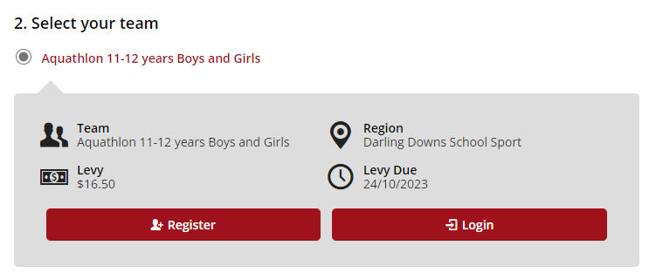

NOMINATIONS CLOSE: FRIDAY, OCTOBER 16 with:
South West School Sport
4572 6513
Email: southwestschoolsport@qed.qld.gov.au

WHAT TO BRING: Togs and towel
Appropriate clothing and footwear
Water
Sunscreen
Completed SW Trial Permission Form

COURSE: 1 km run leg, 200m swim leg and then another 1 km run leg (Aquathlon 2016-2015)
100m swim / 1km run (multi-class aquathlon for students born 2016-2013)
200m swim / 2km run (multi-class aquathlon for students born 2012-2008)

CODE OF CONDUCT: | This event is conducted under the QRSS code of conduct. The QRSS code of conduct can be found on the Queensland Representative School Sport website or using the following QR code: | 
NOMINATION FORM
DISTRICT: ……………………………………………………………
NAME | SCHOOL | DATE OF BIRTH | GENDER
1
2
3
4
5
6
7
8
9
10
CONTACT STAFF MEMBER: ……………………………………...
PHONE NUMBER: ……………………………………………………
NAME OF TEACHER ACCOMPANYING TEAM:………………………………………………

REMINDERS: | - Teams attending without a team official WILL BE INELIGIBLE to compete at the Regional Trials.  - All students must bring a completed SW Trial Permission Form to the regional trial. This will be collected by the Convenor. NO FORM means the student will be unable to trial on the day.
RETURN THIS FORM BY Friday, October 16, 20256 TO: | South West School Sport  southwestschoolsport@qed.qld.gov.au

